SIMPLE SELECT
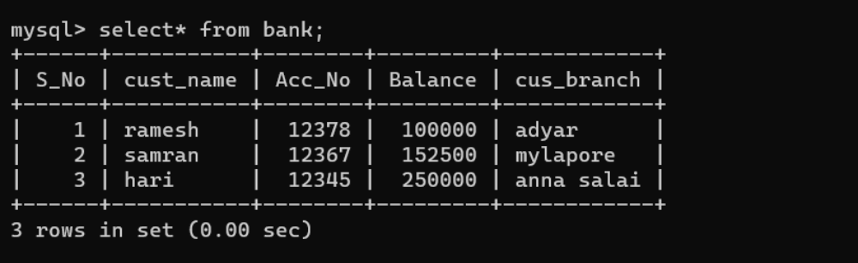

SELECT WITH WHERE CLAUSE

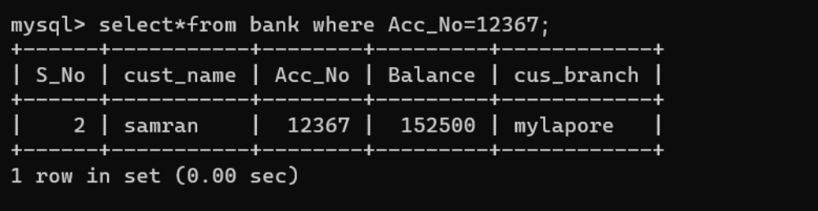

SELECT WITH COMPARISION OPERATOR >
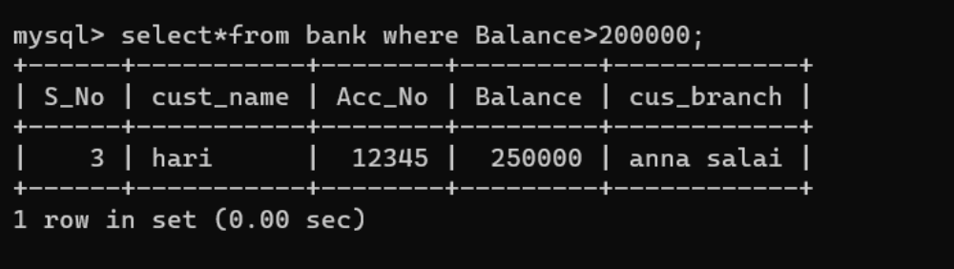

BETWEEN OPERATOR
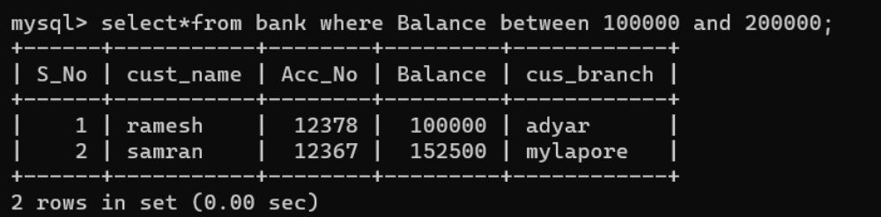

UPDATE OPERATOR
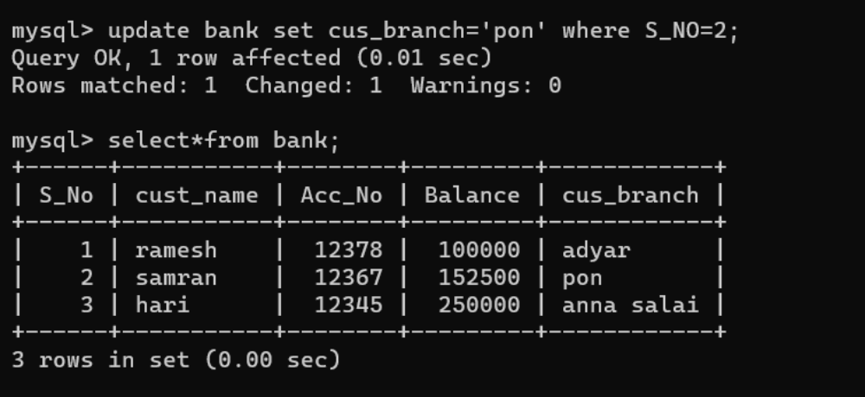

MAXIMUM OPERATOR
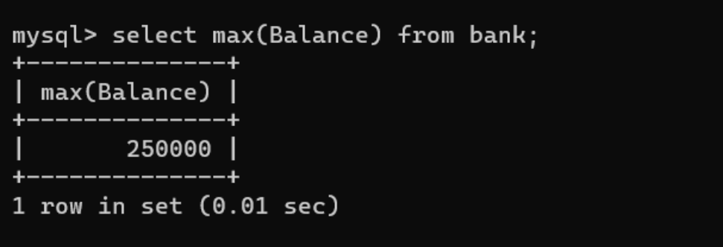

DROP
